FAIRY TAIL LAND ADVENTURE

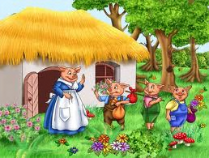

Introduction | Task | Process | Evaluation | Conclusion | Teacher Page

Introduction
Once upon a time there was a teacher pig with little pigs, and one day she said to them: “My students, it is time for you to go out in the world and seek an adventure”. So, bidding their by teacher’s good-bye, the little pigs set out to their adventure. Each pig then ventured off on their own hoping to do interesting things. However, each had difficulties, so they were lonely and scared. Until one pig decided to work together and thought up great ideas to have fun.

The Task
Now, this is your task should you decide to follow this adventure as the pigs did. You are to create a story of your own and design a journey where you have problems and demonstrate the ability to solve them using real life experiences. You are required to complete the following:
- Do research
- Prepare a story of your own
- An oral presentation
Here is the following information that you will require to accomplish this task.
- Library and/or Internet research
- Story must be typed and at minimum 5 pages long.
- Present your story as tri-fold display board or power point.

The Process
To accomplish the task, you will follow these steps. You will be assigned into 3 or 4 groups and chose a story of the list that will be provided to you. In addition you will report back to me for your story approval. Finally you will perform your story in the class.
- Step 1: Pick a story of your choice from the list that I will provide to you. When you make a choice, let your teacher know.

- Step 2: As you pick your story, then you will be placed with the same group that picks the same story. If cannot find a story I will assign one for you.

- Step 3: Gather with your group and start doing your research in the library or the internet. Here are some links to help you with your story. To follow the links, click on the word and press the control button.

- PBS Kids Kid’s Fables Classical Stories
- Children's Classics Fables Ms. Garcia Website

- Step 4: Work together and discuss ideas to your classmates on how to find information on your topic. If it is necessary make a venn diagram, a t-table, or make notes on what you will be discussing in your story.

- Step 4: If you make a tri-fold display board, add pictures and or drawings, be creative, with a power point gather as much information and put it into your slides. Remember creativity counts toward your grade.

- Step 5: Teacher must preview and approve your assignment. Once you have the general ideas then get started.

- Step 6: You will have two weeks to work on this project, and about one hour every afternoon to work together.

*Always ask your teacher for help if you have any questions! Or require further assistance.

Evaluation
Name:__________ Topic:________________ Score:__________
Your assignment will be evaluated by the following rubric:
 | Beginning  1 | Developing  2 | Qualified  3 | Exemplary  4 | Score
Illustrate the story with pictures, slide, and creativity | No diagrams, drawings, models and explanations | Few diagrams and explanations | More diagrams and explanations | Accurate drawings, diagrams, models, posters and group presentation
The details on the story problem and solution. | No explanations of the story | Few explanations of the story | Further explanations of the story | Thorough explains the information on story
Special features, power point or tri-fold | No report on special appearance of the story | Few report on the  special appearance of the story | Further illustration on special appearance of the story | Accurately illustrates special appearance of the story
Relationship with real life experiences | No description of the relationship between life experiences | Few description of the relationship between life experiences | Further description of the relationship between real life experiences | Accurately  describes the relationship between real life experiences

Conclusion
Students should be able to recognize that a fairy tales and fables are fiction and nonfiction consists of real life problems and how to identify them. However fairy tales have a moral dilemma that children should not do things that could have consequences. Recognize the major common characters of the stories and compare/contrast the dilemma of each story being presented.

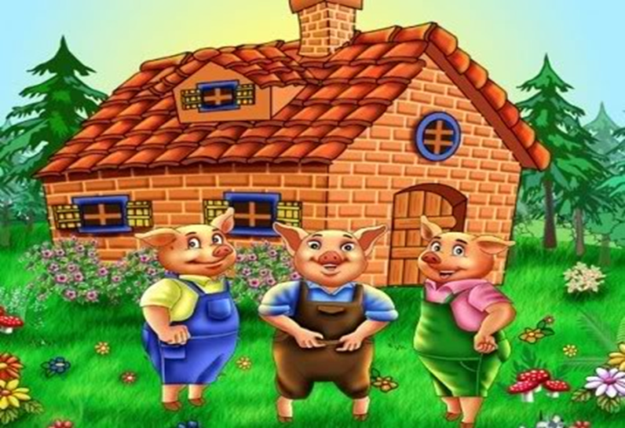

Have Fun!!

Teacher’s Page

Ms. Garcia, a student at Indian River Stat College, majoring in middle ESE/ESOL B.S program. This web-quest is for 3rd grade students. The activity that my students will accomplish is to create a story, work in groups, and then present their final project in class. Students will research, write, and act of their stories.

